File Upload scenario
Weak Prompt: "Generate test cases for file upload."
Analysis: Upon giving this prompt, it suggests the possible scenarios for coverage rather creating test cases.
Strong Prompt using ICEPOT framework
Context :
Generate test cases for airlines domain for File upload functionality requires testing across multiple vectors: file attributes, user actions, boundary limits, and security vulnerabilities.
Instruction:
[strict]Functional only - Positive/negative
[mandatory]Upload allowed formats (e.g., .pdf, .png, .docx) and verify successful processing.
[mandatory]Test file names with spaces, symbols, and special characters (file #1@2026!.pdf).
[Priority]Drag a valid file directly onto the upload zone.
[exact]Select multiple files simultaneously via the file picker (if supported).
[Critical]Generate 10 test cases
Example
TC_ID|Scenario|Steps to execute|test data|expected result|designed by|reviewed by|review comments
Persona
Generate test case as a senior test engineer
Review test case as a test lead
Output
Generate test case in excel format and it should be downloadable
Tone
Professional and concise
Analysis: Upon giving prompt using ICEPOT framework, it generated the specified number of test cases in mentioned template including all the necessary scenarios and information.
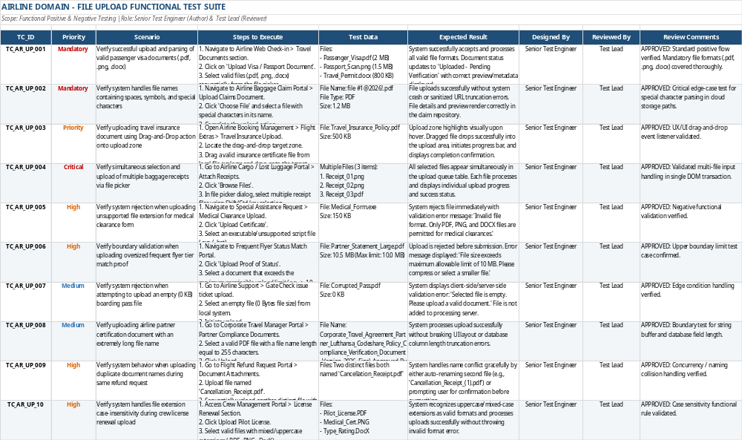

Scenario 3— Shopping Cart
Weak Prompt: " Test the cart functionality.”
Analysis: Upon giving this prompt, it suggests the possible scenarios for coverage rather creating test cases.
Strong Prompt using ICEPOT framework
Context :
Generate test cases for E-Commerce domain for Testing the cart functionality requires verifying core e-commerce operations, user session states, price calculations, and edge cases.
Instruction:
[strict]Functional only - Positive/negative
[mandatory]should cover - Add to Cart,Quantity UpdatesItem Removal and Product Variations functionalities.
[mandatory]Should cover Coupons & Promo Codes.
[Strict]Should cover Session Timeout and Cross-Device Sync,
[Only]Generate 10 test cases
Example
TC_ID|Scenario|Steps to execute|test data|expected result|designed by|reviewed by|review comments
Persona
Generate test case as a senior test engineer
Review test case as a test lead
Output
Generate test case in excel format and it should be downloadable
Tone
Professional and concise
Analysis: Upon giving prompt using ICEPOT framework, it generated the specified number of test cases in mentioned template including all the necessary scenarios and information.
